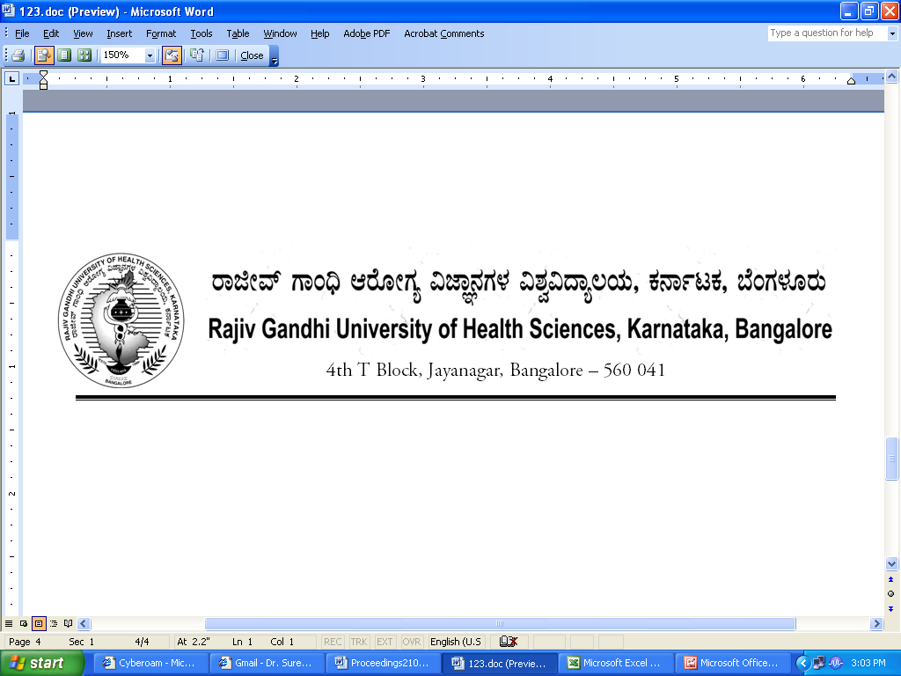Reg (Eva)/M.Sc (N) Panel/June-2018 Date: 15.06.2018

CIRCULAR
To,
The Principals
All Nursing (M.Sc Nursing)
Colleges affiliated to RGUHS

Subject: | Updating the examination panel of M.Sc Nursing – June-2018.
***
Sir/Madam,

With reference to above mentioned subject, the university is completely revamping the existing panel of examiners. Hence you are hereby informed to submit the list of all eligible teaching faculty members of your institution. (Who have minimum 5 years teaching experience and recognized guide from University)

The Principal should fill teachers data as per prescribed format, in your college letter head and it should be signed by the Principal and forward to Registrar (Evaluation) within two weeks after receipt of this letter (Hard copy should be submitted through speed post or courier service).

The same details may be entered in the excel sheet format and forward through given E-Mail ID: registrareva@rguhs.ac.in, drexamrguhs@gmail.com, dr2.exam@rguhs.ac.in

Note:
- The Principal will be responsible for any false or incorrect information. In such instances disciplinary action will be taken as per RGUHS Norms

- All relevant documents with self attested copy should be enclosed

- Teachers email id is mandatory.

KINDLY TREAT THIS AS MOST URGENT

Thanking you,

By Order,

Sd/-
Registrar (Evaluation)
(Dr.M.K.Ramesh)
Rajiv Gandhi University of Health Sciences, Karnataka List of M.Sc Nursing Teachers for inclusion of their names in the Panel of Examiners for the year 2018-19

Name & Address of the College: College Code:
Course offered: ……………………………… Department:
SL No | Name of Faculty with Designation, | TIN No | Date of Birth and age | Qualification with specialization | Date, Month &Year of Passing (Result) |  |  | KNC Registration No. & Date of Renewal | Date of  Joining present institution | Teaching experience at Collegiate level after passing (results)  M. Sc. Nursing |  | PAN No., E- Mail ID and Mobile No.
 |  |  |  |  | UG Nursing | PG Nursing | Others (Specify) | KNC Registration No. & Date of Renewal | Date of  Joining present institution | UG Course | PG course | PAN No., E- Mail ID and Mobile No.

Declaration by the Teacher:

- I declare that the information furnished above is true to the best of my knowledge and I commit myself to take up the any assignment given by university in the above regard. If I am not able to take any assignment, I will justify/ support it with relevant document for example : Medical Certificate in case of sickness
- I also take the responsibility to inform the Registrar (Evaluation), RGUHS, Bangalore, by speed post/registered post, if I leave this institution, within two days of getting relieved from the institution along with copy of the relieving letter.
- I am fully aware that failure to comply with above conditions will lead to deletion of / non inclusion of the name in the panel.

Signature of the Teacher
Certification by the Principal:
- Certified that the information furnished above are true to the best of my knowledge and are according to the records maintained in our college.
- Certified that only the faculty members ( Old & new entrants) who have 3 years and more teaching experience at collegiate level after results of M. Sc. Nursing are included.
- Certified that that the self attested copies of Degree Certificate & Final Year Marks Cards of UG & PG, KNC registration, all experience certificates, form no.16 & copy of PAN card and appointment order, joining report, relieving letter from previous institution (if applicable)of all the above teaching faculty are attached herewith.
- I also take the responsibility to inform the Registrar (Evaluation), RGUHS, Bangalore, by speed post/registered post, if the above teacher leave this institution, within two days of his/her getting relieved from the institution along with copy of the relieving letter.
- I hereby declare that I don’t send any of the teachers name from my institution to enter in the panel of examiners for M.Sc Nursing.

Signature & Seal of the Principal

